
FINAL COLLABORATIVE PROJECT REPORT SMART GARDEN MONITORING SYSTEM

PRESENTED BY:
- DEVAPRIA (025)
- DWI ALDIKA (026)
- DWI OKTRIANA N.R (027)
- DZAWWAS N.A (028)
- EFA FITRIYANI (029)
- FADLAN MUBINA (030)

TEKNIK ELEKTRONIKA INDUSTRI
SMK NEGERI 2 PURWOKERTO
2025
CHAPTER I
INTRODUCTION
  - Background
The "Smart Garden Monitoring" project is driven by the urgent need for resource efficiency and precise environmental control in modern agriculture22. Conventional methods often result in water wastage and uncontrolled microclimate fluctuations detrimental to optimal plant growth23. The primary objective of this project is to realize a mini greenhouse prototype equipped with Smart Watering and Temperature Control automation systems using the ESP32 microcontroller24. Furthermore, the project aims to build a Blynk IoT interface to display real-time sensor data and provide remote manual/automatic control.
  - Purpose
- Prototype Realization: To design and implement a mini greenhouse prototype featuring an integrated Smart Watering and Temperature Control automation system utilizing the ESP32 microcontroller.
- Interface Development: To build a user-friendly Blynk IoT dashboard capable of displaying real-time sensor data and providing immediate manual control options for all actuators from a distance.
- Performance Verification: To rigorously test the system's performance to verify its ability to maintain stable soil moisture (≥ 20%) and air temperature (≤ 31 C) within the predetermined optimal threshold limits.

CHAPTER II
BODY
- Key Components and Theoretical Basis
The system operates on the principles of Smart Farming using IoT, allowing for continuous remote monitoring and automatic environmental regulation.
- Microcontroller: The NodeMCU ESP32 serves as the central control unit, chosen for its powerful dual-core processor and integrated Wi-Fi/Bluetooth capabilities, essential for cloud connectivity (Blynk).
- Sensors: The Capacitive Soil Moisture Sensor provides analog input for measuring soil wetness, and the DHT11 Sensor provides digital input for real-time measurements of air temperature and humidity.
- Actuators: Controlled via a 5V 3 Channel Relay Module, the actuators include a Mini DC Pump (for watering), a Mini DC Fan (for cooling/ventilation), and an LED Lamp.
- Interfaces: The system features a Blynk IoT Dashboard for remote interaction and an OLED Display for local, high-contrast visual status checks.
- Methodology and Implementation
The project followed a standard methodology:
- Design Phase: Creating the Block Diagram (Input ESP32 Output) and designing the electronic circuit using Fritzing, mapping all components to the ESP32 GPIO pins (e.g., Relay 3 for the pump on GPIO 18).
- Hardware Assembly: This involved fabricating the mini greenhouse structure (using acrylic and wood) and mounting the electronic components onto a PCB Board for durability.
- Software Development: Configuring Blynk IoT Datastreams and the Dashboard, followed by writing the core logic in Arduino IDE using C/C++ language, which includes the logic for automatic control and Wi-Fi connection.
- Testing Phase: Comprehensive testing was conducted, including Sensor Calibration, Manual Control Testing via Blynk switches, and Automatic Mode Testing to verify the response of the fan and pump to changes in environmental conditions.
- Results and Performance Discussion
The project successfully implemented a working prototype. The Auto Mode feature, the core of the system, performed reliably according to the programming logic:
- Smart Watering Logic: The Mini Water Pump automatically activates when the Capacitive Soil Moisture Sensor detects that the soil wetness has dropped to or below the programmed threshold of ≤ 20%.
- Temperature Control Logic: The Mini DC Fan automatically turns ON when the DHT11 Sensor records an air temperature reading of ≥31°C, ensuring the internal microclimate remains stable.
Both the remote Blynk IoT Dashboard (providing real-time graphs and switches) and the local OLED display (offering three information modes) proved effective as intuitive user interfaces for monitoring and control.

CHAPTER III
CLONCLUSION
Based on the design, implementation, and testing of the IoT-based Smart Garden system, it can be concluded that the monitoring and control system for the mini greenhouse has been successfully realized. The ESP32 microcontroller functions optimally as the main control unit, seamlessly integrated with the DHT11 sensor for detecting temperature and air humidity, as well as the Capacitive Soil Moisture sensor for measuring soil moisture levels. The Auto Mode feature designed within the software operates according to the specified algorithm, where the cooling fan (Relay 2) turns on automatically when the temperature reaches ≥ 31°C, and the water pump (Relay 3) activates when soil moisture drops below ≤ 20%.
In addition to the automation performance, the integration with the Blynk IoT platform proves effective as a remote interface. Users are able to monitor real-time sensor data graphs, control manual switches, and activate the automatic mode via virtual buttons with fast response times. On the other hand, the local interface consisting of an OLED display and a physical button successfully displays three different information modes (Logo, Sensor Data, and Member List) making it convenient for users to check the device status directly without relying entirely on the smartphone application.

CHAPTER 4
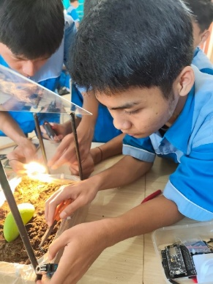
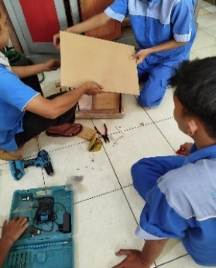
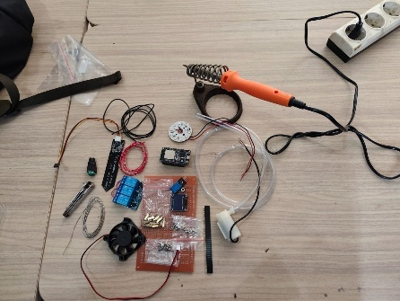
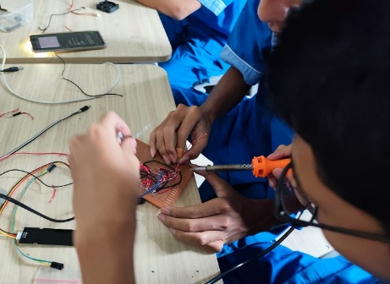
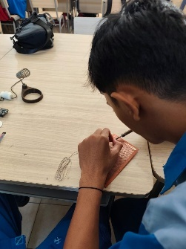
ATTACHMENT
